Deep Learning Quick

Machine learning => Analyzes and learns from the data and then makes prediction about new data.
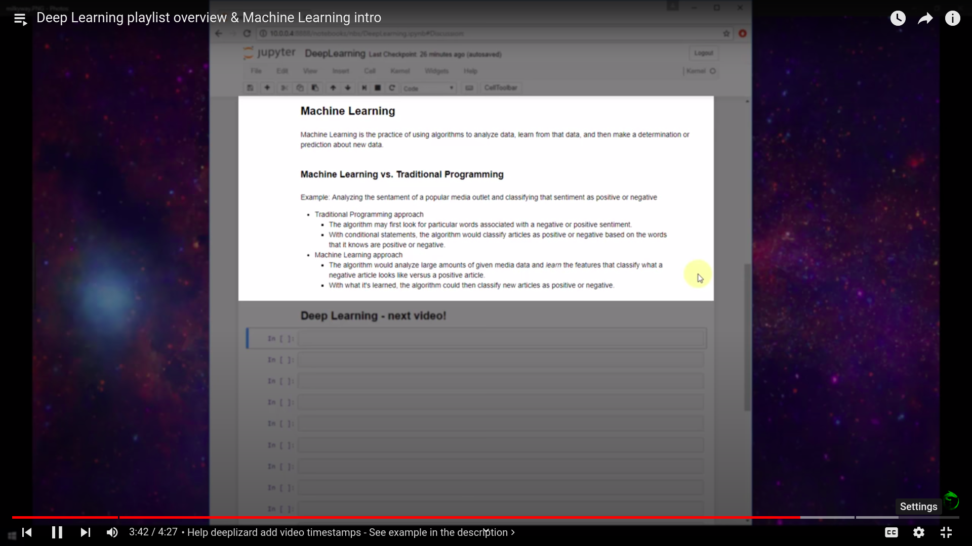

Deep learning => It is a subset of machine learning that uses algorithms deeply inspired by the structure and function of brains neural network.
It can be supervised(when data is already been labelled) or unsupervised(when data is not labelled).

Models used in deep learning are called Arificial Neural Network.
Artificial Neural Network is inspired by brains neural network which are based on collection of connected units called artificial neurons or neurons.
Each connection between the neurons can transmit signals from one neuron to other. This way neurons can transmit signals over different layers. (Namely input layer, hidden layer & output layer)

Layers in an Artificial neural network
1)Dense layer(connects each input with each output)
2)Convolutional layer(used while working with image data)
3)Pooling layer
4)Recurrent layer(used while working with time series data)
5)Normalization layer
6)Others

Why ? => Different layers performs different kind of transformation
Weights? => Number between 0 and 1 which represent strength of connection

Note: input will be multiplied by the weights and the resulting sum is passed to the activation function which returns the result in between 0 to 1. This will be passed to next layers.

Activation function=>

sigmoid : (e^x)/(e^(x+1)) => value between 0 and 1
relu(rectified linear unit) : max(0,x)

Optimizer=>

Basically when models starts training it’s weights get optimized with the help of some algorithms
Ex: Stochastic Gradient Descent (SGD) => Intension is to minimize the loss function

Loss is basically difference between what the actual label is and what the model predicts.
The loss is minimized by considering optimized values for the weights.

Single pass of data through the model is called EPOCH.
Same data will be passed over multiple EPOCH’s and hence this way model will be learning.

While training, error is computed by looking at what is the actual output and what is the predicted value.
Then [ d(loss)/d(one of the weight value) ] also called gradient of loss which is computed which is multiplied by very small value (Ex. 0.001) called learning rate. Based on this value weights will be changed and keeps getting closer and closer to the optimized value.
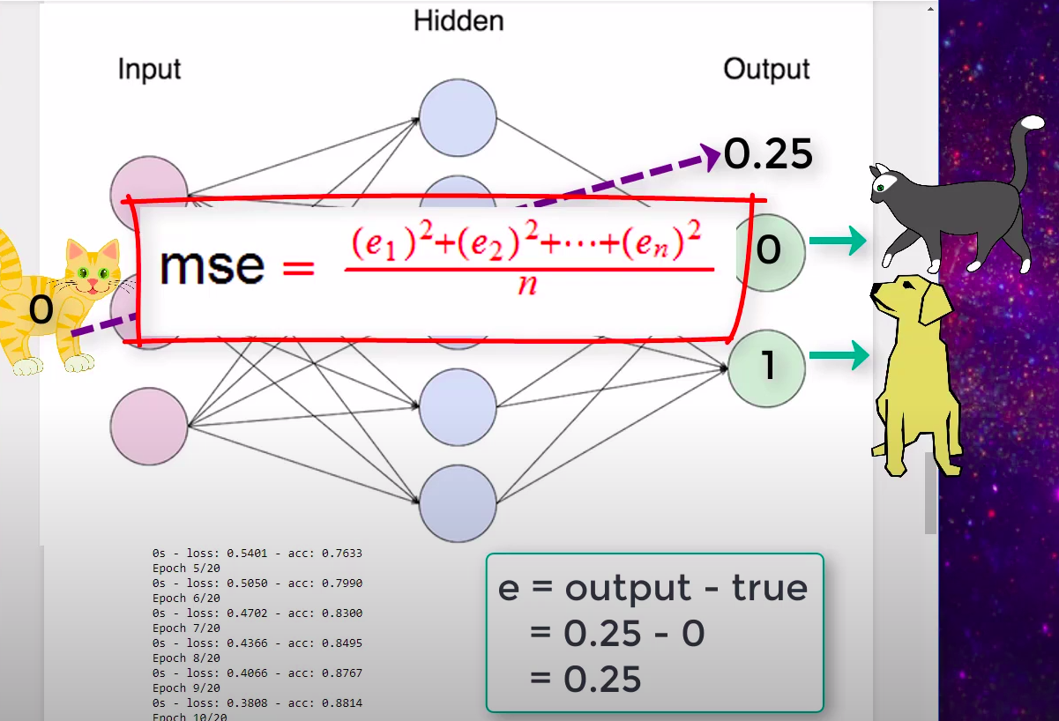

Loss function => Here e1,e2...en are errors
for different values of output

